**Hardware Assembly and Fault Diagnosis**

Table of Contents

**Circuit Boards** 2

**BOM table** 6

**Installation Notes** 9

**Installation Check** 10

**Calibration** 10

**Troubleshooting** 15

**(Revision 20201010 for CT3-2019)**

# **Circuit Boards**

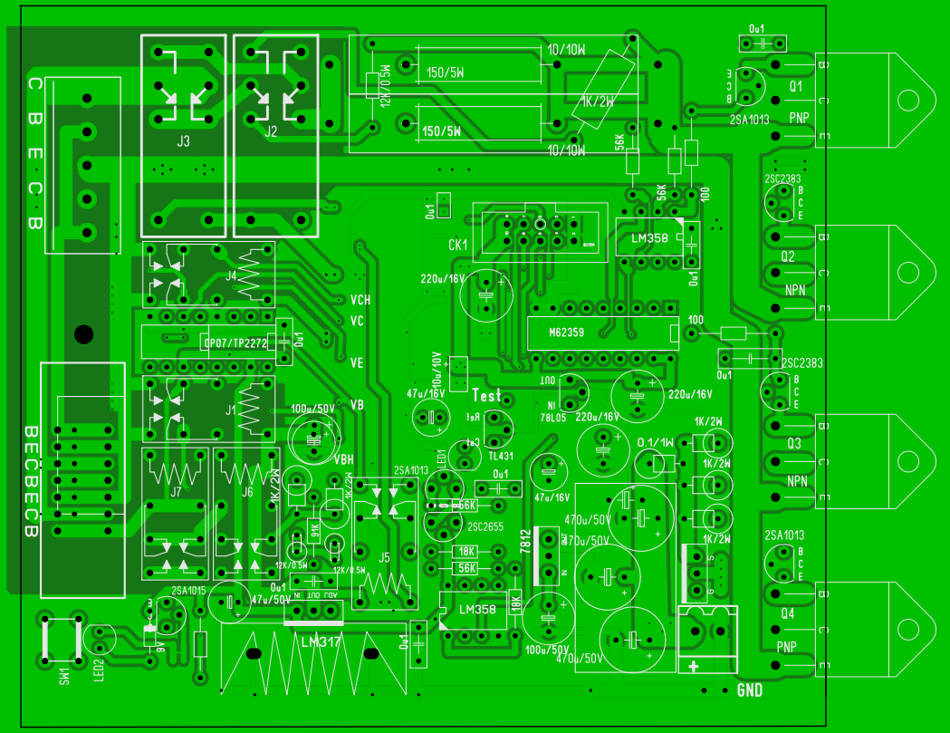

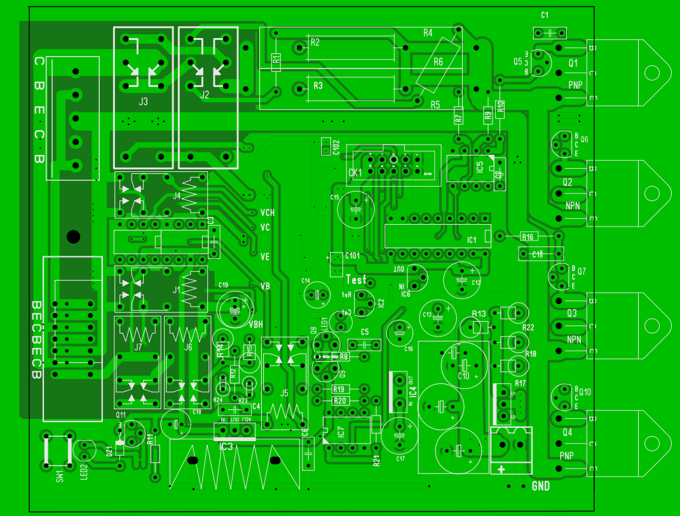

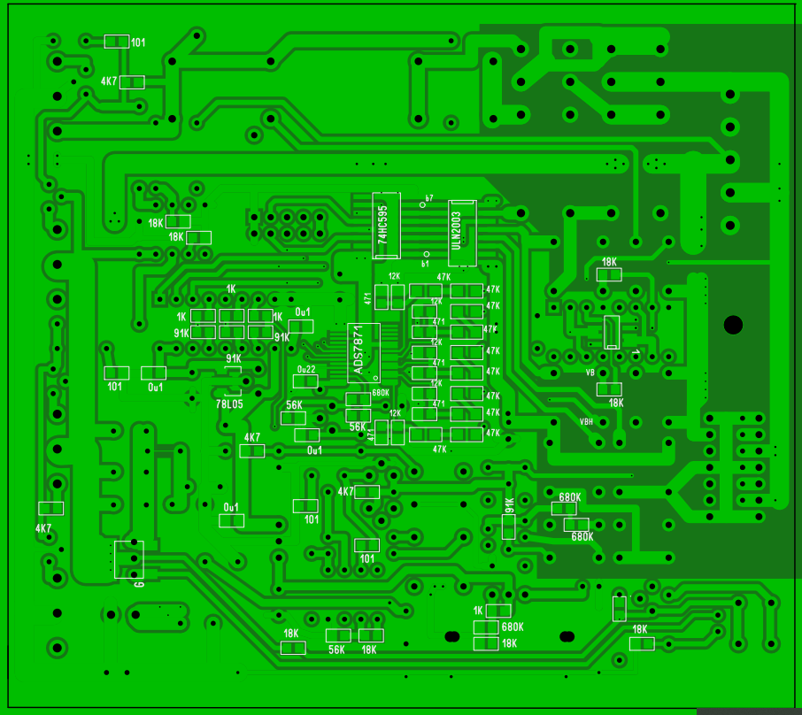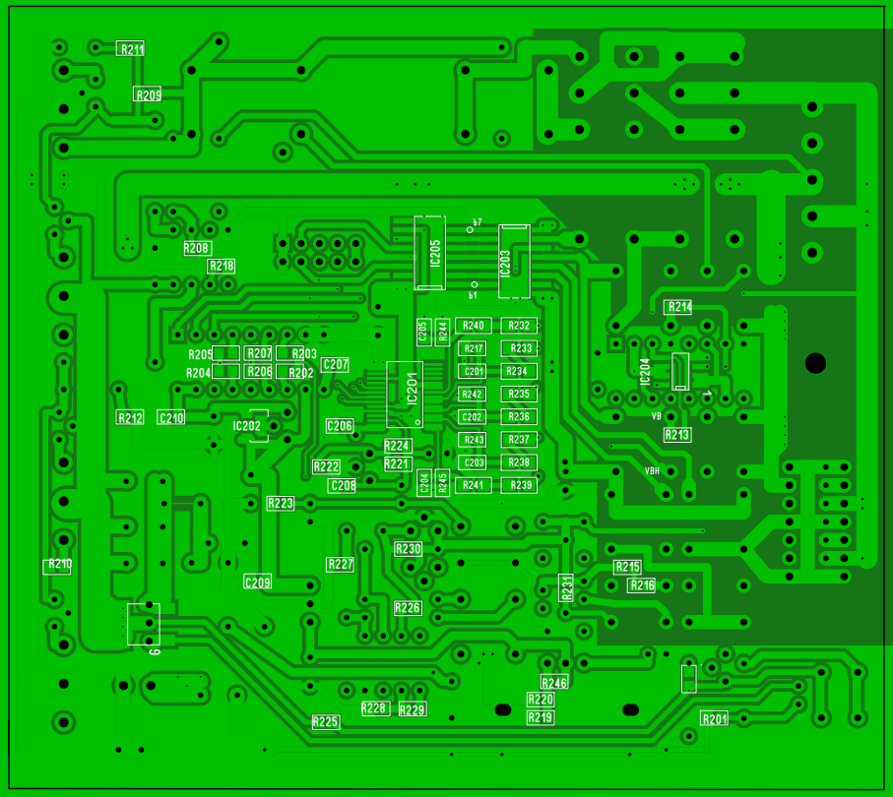

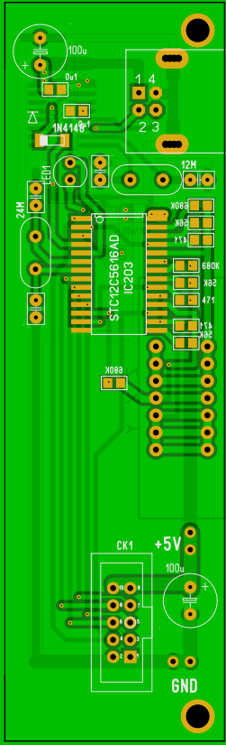 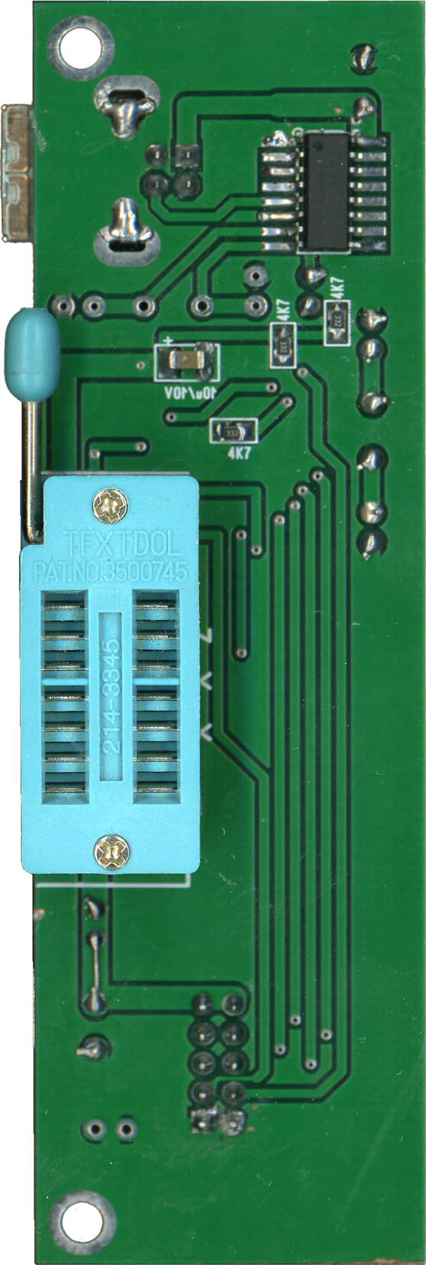

# **BOM table**

|  |  |  |  |  |
| --- | --- | --- | --- | --- |
| **Name** | **Value** | **Layer** | **Package** | **(Power Board)** |
| C201 | 470P | Bottom | 0805 |  |
| C202 | 470P | Bottom | 0805 |  |
| C203 | 470P | Bottom | 0805 |  |
| C204 | 470P | Bottom | 0805 |  |
| C205 | 470P | Bottom | 0805 |  |
| C206 | 0u22 | Bottom | 0805 |  |
| C207 | 0u1 | Bottom | 0805 |  |
| C208 | 0u1 | Bottom | 0805 |  |
| C209 | 0u1 | Bottom | 0805 |  |
| C210 | 0u1 | Bottom | 0805 |  |
| IC201 | ADS7871 | Bottom | SSOP28 |  |
| IC202 | 78L05 | Bottom | SOT89 | If install IC202 then no install IC6. |
| IC203 | ULN2003 | Bottom | SOP16 |  |
| IC204 | OP07|TP2272 | Bottom|Top | DIP8|SOP8 | Install either OP07(DIP)×2 or TP2272(SOP)×1. |
| IC205 | 74HC595 | Bottom | SOP16 |  |
| R201 | 18K | Bottom | 0805 |  |
| R202 | 91K | Bottom | 0805 |  |
| R203 | 1K | Bottom | 0805 |  |
| R204 | 91K | Bottom | 0805 |  |
| R205 | 1K | Bottom | 0805 |  |
| R206 | 91K | Bottom | 0805 |  |
| R207 | 1K | Bottom | 0805 |  |
| R208 | 18K | Bottom | 0805 |  |
| R209 | 4K7 | Bottom | 0805 |  |
| R210 | 4K7 | Bottom | 0805 |  |
| R211 | 101 | Bottom | 0805 |  |
| R212 | 101 | Bottom | 0805 |  |
| R213 | 18K | Bottom | 0805 |  |
| R214 | 18K | Bottom | 0805 |  |
| R215 | 680K | Bottom | 0805 |  |
| R216 | 680K | Bottom | 0805 |  |
| R217 | 12K | Bottom | 0805 |  |
| R218 | 18K | Bottom | 0805 |  |
| R219 | 18K | Bottom | 0805 |  |
| R220 | 680K | Bottom | 0805 |  |
| R221 | 56K | Bottom | 0805 |  |
| R222 | 56K | Bottom | 0805 |  |
| R223 | 4K7 | Bottom | 0805 |  |
| R224 | 680K | Bottom | 0805 |  |
| R225 | 18K | Bottom | 0805 |  |
| R226 | 101 | Bottom | 0805 |  |
| R227 | 101 | Bottom | 0805 |  |
| R228 | 56K | Bottom | 0805 |  |
| R229 | 18K | Bottom | 0805 |  |
| R230 | 4K7 | Bottom | 0805 |  |
| R231 | 91K | Bottom | 0805 |  |
| R232 | 47K | Bottom | 1206 |  |
| R233 | 47K | Bottom | 1206 |  |
| R234 | 47K | Bottom | 1206 |  |
| R235 | 47K | Bottom | 1206 |  |
| R236 | 47K | Bottom | 1206 |  |
| R237 | 47K | Bottom | 1206 |  |
| R238 | 47K | Bottom | 1206 |  |
| R239 | 47K | Bottom | 1206 |  |
| R240 | 47K | Bottom | 1206 |  |
| R241 | 47K | Bottom | 1206 |  |
| R242 | 12K | Bottom | 0805 |  |
| R243 | 12K | Bottom | 0805 |  |
| R244 | 12K | Bottom | 0805 |  |
| R245 | 12K | Bottom | 0805 |  |
| R246 | 1K | Bottom | 0805 |  |
| BEC… | KF141V-7|5 | Top |  | Output ZIF terminal BECBECB|ECBEC. |
| C1 | 0u1 | Top |  |  |
| C101 | 10u/10V | Top | 1206 |  |
| C102 | 0u1 | Top | 0805 |  |
| C11 | 0u1 | Top |  |  |
| C12 | 220u/16V | Top |  |  |
| C13 | 220u/16V | Top |  |  |
| C14 | 47u/16V | Top |  |  |
| C15 | 220u/16V | Top |  |  |
| C16 | 47u/16V | Top |  |  |
| C17 | 100u/50V | Top |  |  |
| C18 | 47u/50V | Top |  |  |
| C19 | 100u/50V | Top |  |  |
| C2 | 0u1 | Top |  |  |
| C3 | 0u1 | Top |  |  |
| C4 | 0u1 | Top |  |  |
| C5 | 0u1 | Top |  |  |
| C6 | 0u1 | Top |  |  |
| C7 | 470u/50V | Top |  |  |
| C8 | 470u/50V | Top |  |  |
| C9 | 470u/50V | Top |  |  |
| CBE… | KF301 5P | Top |  | Output screw terminal CBECB. |
| CK1 | IDC-10M | Top |  |  |
| DZ1 | 9V Zener | Top |  |  |
| IC1 | M62359 | Top | DIP8 |  |
| IC2 | TL431 | Top | TO-92 |  |
| IC3 | LM317 | Top | TO-220 |  |
| IC4 | 7812 | Top | TO-220 |  |
| IC5 | LM358 | Top | DIP8 | Use socket. |
| IC6 | 78L05 | Top | TO-92 | If install IC6 then no install IC202. |
| IC7 | LM358 | Top | DIP8 | Use socket. |
| J1 | Omrom G5V | Top |  | 1A, 24V, 200~500mW |
| J2 | Omrom G2R | Top |  | 5A, 24V, 360~530mW |
| J3 | Omrom G2R | Top |  | 5A, 24V, 360~530mW |
| J4 | Omrom G5V | Top |  | 1A, 24V, 200~500mW |
| J5 | Omrom G5V | Top |  | 1A, 24V, 200~500mW |
| J6 | Omrom G5V | Top |  | 1A, 24V, 200~500mW |
| J7 | Omrom G5V | Top |  | 1A, 24V, 200~500mW |
| LED1 | Red GaAsP | Top | 3mm | Requirement Vf=1.8V. |
| LED2 | Red GaAsP | Top | 3mm | Requirement Vf=1.8V. |
| Power+ | HT396V 2P | Top |  | Use with HT396K-3.96-2P plug. |
| Q1 | PNP 5A/50V/125W | Top | TO-3P | >60V, >5A, >75W, Egsample:TIP147 |
| Q10 | 2SA1013 | Top | TO-92L | If Q4 is Darlington,then short the B-E of Q10. |
| Q11 | 2SA1015 | Top | TO-92L |  |
| Q2 | NPN 5A/50V/125W | Top | TO-3P | >60V, >5A, >75W, Egsample:TIP142 |
| Q3 | NPN 5A/50V/125W | Top | TO-3P | >60V, >5A, >75W, Egsample:TIP142 |
| Q4 | PNP 5A/50V/125W | Top | TO-3P | >60V, >5A, >75W, Egsample:TIP147 |
| Q5 | 2SA1013 | Top | TO-92L | If Q1 is Darlington,then short the B-E of Q5. |
| Q6 | 2SC2383 | Top | TO-92L | If Q2 is Darlington,then short the B-E of Q6. |
| Q7 | 2SC2383 | Top | TO-92L | If Q3 is Darlington,then short the B-E of Q7. |
| Q8 | 2SA1013 | Top | TO-92 |  |
| Q9 | 2SC2383 | Top | TO-92L |  |
| Q? | FQP11P06 | Top | TO-220 |  |
| R1 | 12K/0.5W | Top |  |  |
| R10 | 100 | Top |  |  |
| R11 | 100 | Top |  |  |
| R12 | 91K | Top |  |  |
| R13 | 0.1/1W | Top |  |  |
| R14 | 1K/2W | Top |  |  |
| R15 | 1K/2W | Top |  |  |
| R16 | 100 | Top |  |  |
| R17 | 1K/2W | Top |  |  |
| R18 | 1K/2W | Top |  |  |
| R19 | 18K | Top |  |  |
| R2 | 150/5W | Top |  |  |
| R20 | 56K | Top |  |  |
| R21 | 18K | Top |  |  |
| R22 | 1K/2W | Top |  |  |
| R23 | 12K/0.5W | Top |  |  |
| R24 | 12K/0.5W | Top |  |  |
| R3 | 150/5W | Top |  |  |
| R4 | 10/10W | Top |  |  |
| R5 | 10/10W | Top |  |  |
| R6 | 1K/2W | Top |  |  |
| R7 | 56K | Top |  |  |
| R8 | 56K | Top |  |  |
| R9 | 56K | Top |  |  |
| SW1 | PB NO | Top |  | Optional overcurrent reset pushbutton. |
|  |  |  |  |  |
| **Name** | **Value** | **Layer** | **Package** | **(MCU Board)** |
| C? | 10u/10V | Bottom | 1206 |  |
| C? | 470u/16V | Top |  |  |
| C? | 0u1 | Top | 0805 |  |
| C? | 0u1 | Top | 0805 |  |
| C? | 100u/10V | Top |  |  |
| C? | 20p | Top |  |  |
| C? | 20p | Top |  |  |
| C? | 20p | Top |  | Populate only if CH340G chip is installed. |
| C? | 20p | Top |  | Populate only if CH340G chip is installed. |
| CK1 | IDC-10M 90° | Top |  |  |
| D? | 1N4148 | Top |  |  |
| IC? | CH340C|G | Bottom | SOP16 | Normally install CH340C chip, CH340G is optional. |
| IC? | STC12C5608AD | Top | SOP28 |  |
| LED1 | Red GaAsP | Top | 3mm | Requirement Vf=1.8V. |
| R? | 3K3 | Bottom | 0805 |  |
| R? | 3K3 | Bottom | 0805 |  |
| R? | 3K3 | Bottom | 0805 |  |
| R? | 680K | Top | 0805 |  |
| R? | 56K | Top | 0805 |  |
| R? | 470 | Top | 0805 |  |
| R? | 680K | Top | 0805 |  |
| R? | 56K | Top | 0805 |  |
| R? | 470 | Top | 0805 |  |
| R? | 680K | Top | 0805 |  |
| R? | 56K | Top | 0805 |  |
| R? | 470 | Top | 0805 |  |
| Y? | 24MHz | Top |  |  |
| Y? | 12MHz | Top |  | Populate only if CH340G chip is installed. |
| ZXY | 214-3345 | Bottom |  | TexTool ZIF socket for DIP14. |
| 1234 | USB-B 90° | Top |  |  |

# **Installation Notes**

**1.** Q1-Q4 can be either ordinary power transistors or Darlingtons. If a Darlington is installed for Q1-Q4 is installed then Q5/Q6/Q7/Q10 must not be installed and the base of each must be jumpered to the emitter by inserting wire jumpers at points 1 & 2 as shown in the schematic below. The required transistor parameters are >60V, >5A, >75W.  
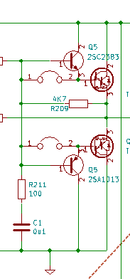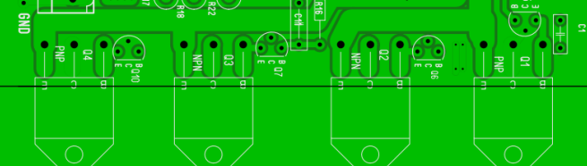

**2.** The 78L05 voltage regulator can be installed to the PCB either on the foil side as an SOT89, or on the component side as TO-92, but only one or the other can be installed.

**3.** Only one type of op-amp TP2272/OP07 may be installed at any given time. If a TP2272 dual op-amp SOP-8 is installed to the PCB foil side, then do not install either of the two OP07 P-DIP packages to the component side. Note that the P-DIP closest to the edge of the PCB corresponds to TP2272A pins 1/2/3 and the other one to TP2272B pins 5/6/7.

**4.** In the over-current protection circuit, there is a thin PCB trace under R13 (0.1 ohm) shorting this resistor. This is used to adjust the over-current protection trip point. If the protection lamp does not light up above 4A then you can cut the short-circuit trace, thereby increasing the resistance of R13. It is recommended that the overcurrent protection should trip beyond 4A because the relays, power transistors and connection terminals etc. are only designed to handle 5A max.

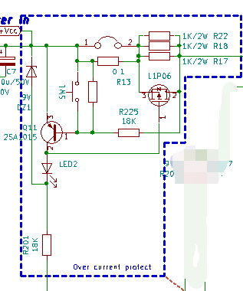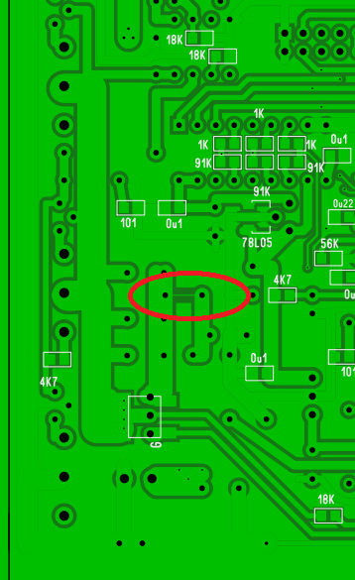

**5.** All relays are 24V, double pole double throw. Two are pin-compatible with G2R, and the other five with G5V. For example G2R-2-H-DC24V and G5V-2-H1-DC24V.

**6.** Replacement of op amps: The LM358 op-amps in the power amplifiers require a working voltage >= 40V, single power supply operation, and stable unity gain. The OP07/TP2272 op-amps requires working voltage >= 40V, stable unity gain, high input impedance, an offset voltage < 1mV, and a common mode input voltage range of Vee+2 ~ Vcc-2.

# **Installation Check**

After installation measure the power supply voltages at LM317 = 24V, 7812 = 12V, and 78L05 = 5V to ensure they are all within 5% tolerance. Then power down and insert the MCU board. Upon power-up the MCU board LED should flashes 3~4 times, indicating that the MCU board self-check has passed. At this point the “Test” terminal on the measurement board should measure about 4.8V (IC201 Vref out), indicating that the MCU has successfully connected to the ADC and that the ADC reference voltage on the board (IC2, TL431) is also normal. If the MCU board is not connected then the voltage of this “Test” point will be random.

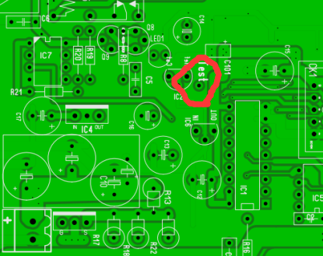

# **Calibration**

If the voltage references TL431 or 78L05 are replaced on the measurement board the ADC and DAC parameters must be reconfigured.  
  
**1.** Connect the curve tracer to a PC using the USB cable and start the curve tracer program. Then select from the menu “Options->config” to access the Preferences dialog and click the “Auto Detect & Get Parameter” button. It should respond with “Parameter have get from Device”, indicating that the connection succeeded. If not then check Windows Device Manager to ensure that the curve tracer shows up under Ports(COM & LPT).

**2.** Still within the “Options->Config” Preferences dialog box, click on the tab “ADC Parameters” and set the ADC channel parameters as shown in the figure below:

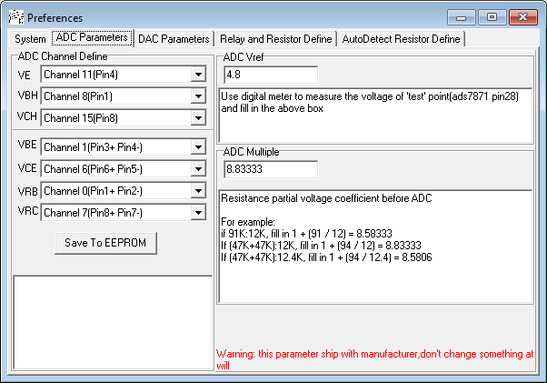

Now use a multimeter to measure the voltage of the “Test” point and enter the value into the box labelled “ADC Vref” shown in the figure above.

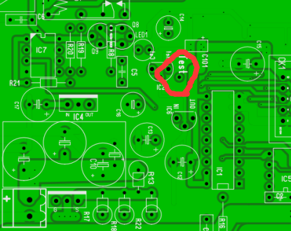

The ADC voltage divider coefficients need to be entered in according to the actual voltage divider resistances installed on the board. Determine the voltage divider resistance by inspecting the actual resistor values on the back of the curve tracer circuit board as shown in the figure below. The voltage divider resistances on some boards are 47K+47K:12K from which the ADC divider coefficient can be calculated as (47+47)/12+1 = 8.8333, whereas on other boards the voltage divider resistance is a combination of 47K+47K:12.4K which correspondingly calculates to (47K+47K)/12.4K+1 = 8.5806. Enter the correct value for your specific PCB into the box titled “ADC Multiple” shown in the figure above.

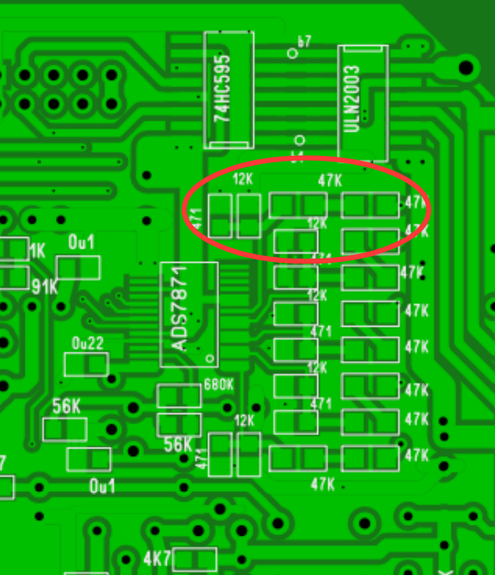

After filling in both of the values discussed above, click the "Save to EEPROM" button to permanently store the ADC parameters. When writing to EEPROM the program will prompt for a password. The password is: ct3

**3.** Still within the “Options->Config” Preferences dialog box, click now on the “DAC Parameters” tab to open it as shown below. This tab is used to set the reference voltage of the DAC. Each of the B/C/E3 channels is driven by its respective main and sub channel. The mixing ratio of each main and sub channel pair will need to be set.

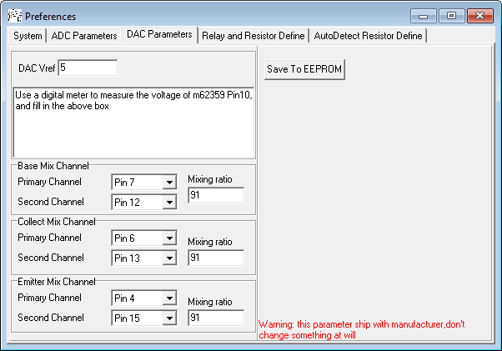

First use a multimeter to measure the DAC reference voltage on pin 18 of IC1 (M62359) and enter this voltage into the "DAC Vref" box illustrated in the figure above. The value should be close to 5 volts. The mixing ratio is the ratio of the resistances in the main and sub channel paths from the primary and secondary DAC channels to each of the op-amps where the voltages are summed. Some boards have 56K:1K in which case the mixing ratio is 56, while other boards have 91K:1K so the mixing ratio is 91. Inspect the resistor values on the rear of your board as shown below, and enter the correct value for each channel into each corresponding “Mixing ratio” box shown in the figure above. Then click the "Save to EEPROM" button and provide the password when prompted. The password is: ct3

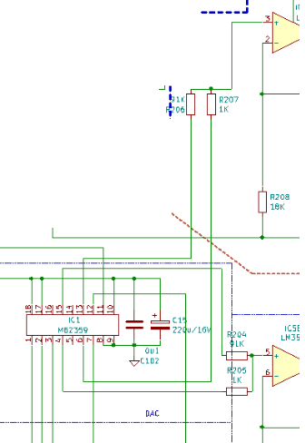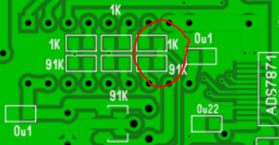

**4.** Still within the “Options->Config” Preferences dialog box, select the tab "Relay and Range Definition".

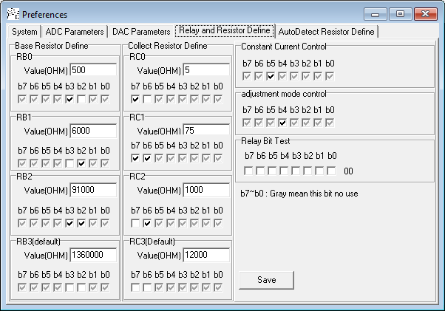

Here we define the range resistors values in the RC and RB relay switching circuits, as well as which digital bits control which relays. The control bits b7-b0 are generally set as shown in the figure above. Note also that the bit definition for “constant current control” applies to relay J5, and the definition for “adjustment mode control” to both relays J1/J4.

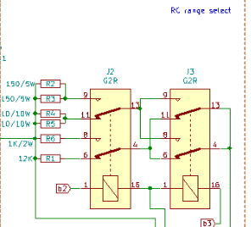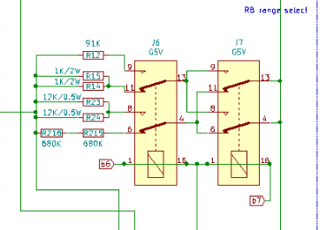

The resistances are entered in accordance with the actual resistor values installed on the circuit board. The component locations of resistors RC0~RC3 and RB0~RB3 are as called out below.

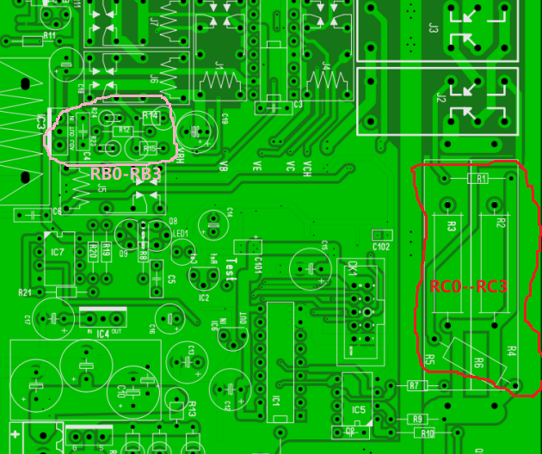

Generally RC0~RC3 are "two 10 ohms in parallel / two 150 ohms in parallel / single 1K / single 12K", while RB0~RB3 are "two 1K in parallel / two 12K in parallel / single 91K / two 680K in series". Therefore RC0~RC3 are filled in with 5/75/1000/12000, while RB0~RB3 are filled in with 500/6000/91000/1360000 respectively. It is recommended to increase the resistance values in proportion to each other in order to achieve a seamless ranging.

**5.** Configuration under the tab “AutoDetect Resistor Define” as shown below, is generally not necessary because the MCU board has been preconfigured before leaving the factory where the values were already saved into EEPROM.

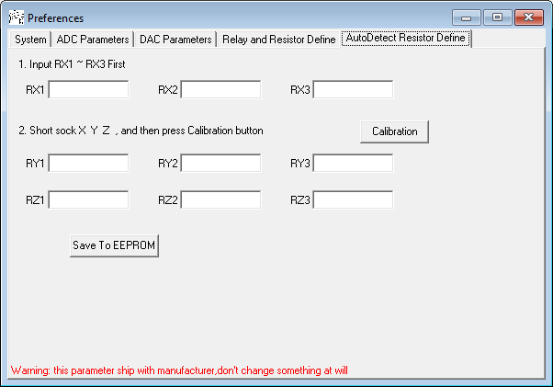

# **Troubleshooting**

**0.** First restore the original ads7871_v3s.ini configuration file to the installation directory on the computer. It can be obtained by downloading the entire package again from the place where the software was originally downloaded. Open the curve tracer housing by removing the 2 lower screws at rear and 2 upper screws at front before continuing.

**1.** Connect the curve tracer USB cable to the PC and open Windows Device Manager as shown below. Expand the item named “Ports (COM & LPT)” and then you should see the “USB-SERIAL CH340” device as well as the COM port number that Windows assigned to it. If it is missing then check the USB cable or if the CH340 chip is damaged.

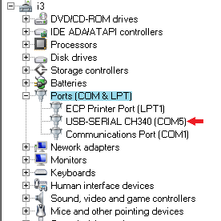 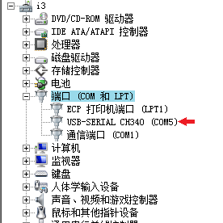

**2.** Power on and you should see the LED on the MCU board flash 3~4 times, indicating that the MCU self-test has passed. If there is no flashing but the +5V power supply is normal then please contact the manufacturer.

**3.** Run the program at the PC and click menu “Options->Config”, then click the “Auto Detect & Get Parameter” button shown below. If you get "Parameter have get from device" then the computer and curve tracer have successfully connected. If it shows “Device not found” after a time-out even though the previous 2 steps succeeded, then please contact the manufacturer.

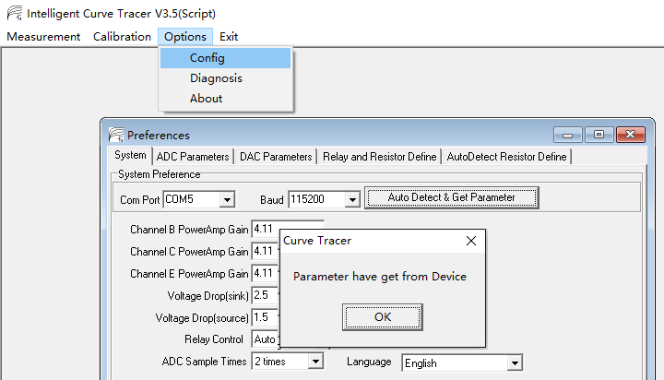

**4.** Use a multimeter to measure the voltage of the “Test” point on the board as shown in the schematic below, to see if it is about 4.8V. If it is not correct then there may be a problem with the ADS7871, or with the TL431 and its power supply, or with the connection between the MCU board and the measurement board when it can’t initialize.

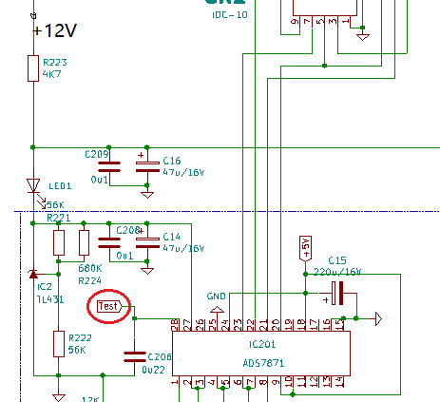

**5.** Select menu “Options->Diagnosis” but leave the “Current Relay Test” and “Calibration Relay Test” boxes unchecked as shown below. Set the same numeric values as are shown in the red box below and then click the “Output” button. At this point the system will set “Channel B” to output 5V, Channel C” to output 15V, and “Channel E” to output 25V.

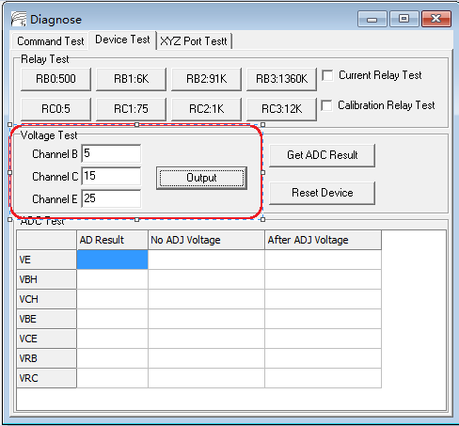

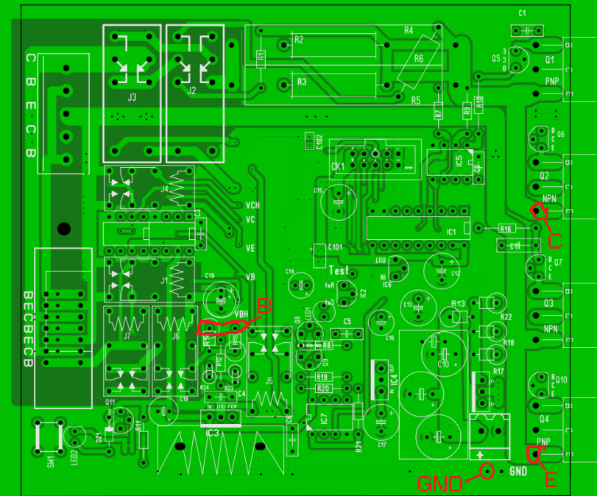

The amplification factor of each power amplifier is 1+56K/18K = 4.11 and because Channel B is set to 5V, Channel C to 15V, and Channel E to 25V, then the input voltage into each of the three power amplifiers should be about 1.2V at pin 3 of IC7, 3.6V at pin 3 of IC5, and 6.1V at pin 5 of IC5. If the voltages are correct then the DAC is operating normally.

Then measure the Channel E voltage from the emitter of Q4 to ground to make sure it is about 25V. Measure the Channel C voltage from the emitter of Q2 to ground to verify 15V, and measure the Channel B voltage at R14/R15 terminal with respect to ground to verify about 5V. If these are all correct then the power amplifier of each channel is also working normally.

**6.** Without exiting the previous step, click on the “Get ADC Result” button. The system will use ADC to measure 7 voltage values VE/VBH/VCH/VBE/VCE/VEB/VRC and display them as shown by the red box in the table below.

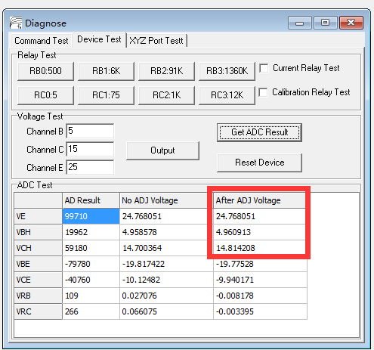

Verify that the values displayed in the red box for VE, VCH, and VBH are close to the values previously set for each of the corresponding “Channel E”, “Channel C”, and “Channel B”, as seen in the “Voltage Test” area in the above figure. This confirms that the ADC is working properly. If the measurements are abnormal then a relay is usually faulty.

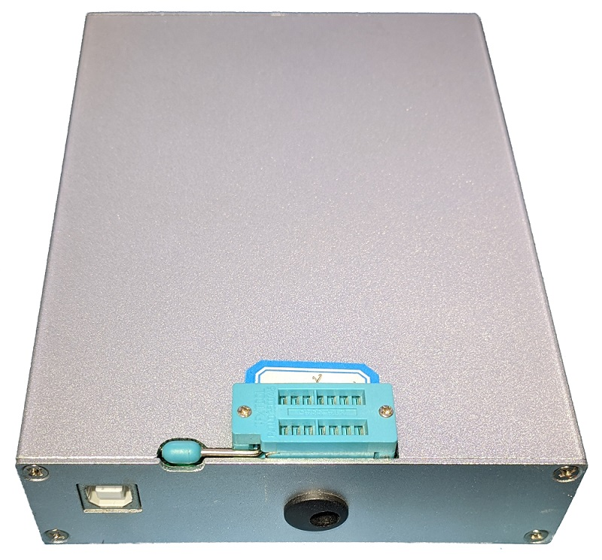

The nice modification shown above for the test socket lever can be made with a set of small needle files.